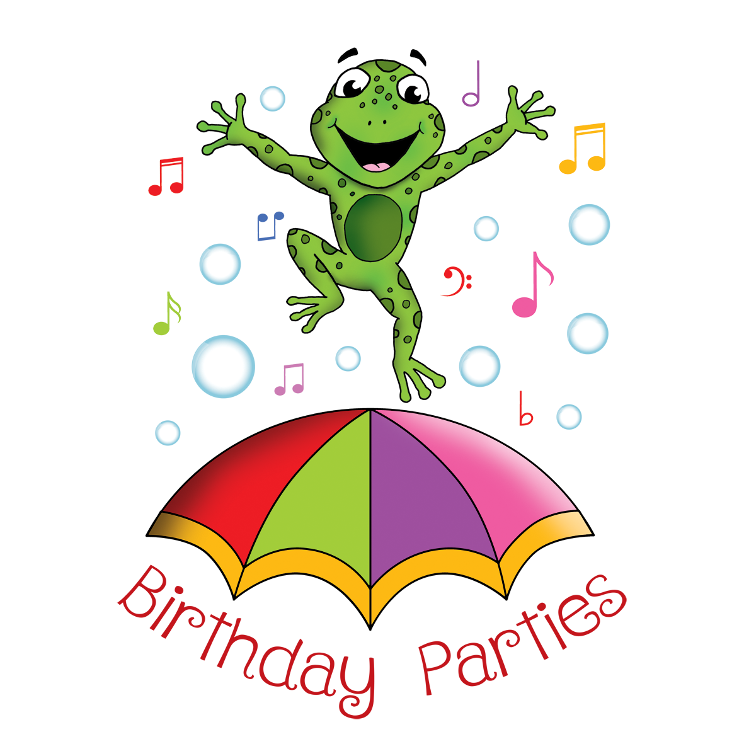
The Story Frog
Birthday Parties
Parties that sparkle!

Thank you so much for enquiring about birthday parties with The Story Frog, we are so excited to begin working with you and start your Story frog adventure, this is where the fun begins….
In order for us to create your child’s perfect party, we need a few details.
Please read through our party packages and activity programmes before completing and returning the form below, to thestoryfrogsam@gmail.com

Our parties are set into 2 packages with the option of 5 activity programmes to choose from.
Our standard story package is based on one story frog leader with up to 15 children with the option of one of 5 activity programmes, which include:

Package 1
One whole hour of Story Frog fun for up to 15 children with one Story Frog leader to include:
Sparkly Story Frog Welcome
Story’s Parachute Games
Story’s Dough Disco- dance to the beat with Story as he challenges everyone to dance to the beat with their playdough!
Story’s Activity Stations - 5 fun filled creative activities based on selected programme.
Story telling - A chance to wind down and enjoy the birthday child’s favourite story, perhaps based on their chosen themed activity programme.
Bubble Disco- all the Story Frog favourite rhymes to sing and dance to under disco lights and of course bubbles.
Happy Birthday & Goodbye - a big Story Frog thank you and goodbye with a Story goody bag distributed as we sing a Story Frog Happy Birthday!
Price £95

Package 2
Two hours of Story Frog fun for up to 15 children with one Story Frog leader to include:
All of package 1 plus:
Messy Madness- up to 5 additional stations of crazy, fun and exciting messy play. This can be themed to your chosen programme or you can request maximum messiness with varying messy activities suggested by your Story Frog Leader.
Take away Happy Birthday Hand Canvas - let all your guests mark the birthday child’s birthday with a handprint /fingerprint on their own personalised canvas
Price £175

(Please note none of our packages include venue or party food or party bags)

Activity programmes :

Story’s Woodland Adventure- Join Story as he goes on a ramble through the woods, will you discover a woodland creature or perhaps a flower fairy?

Story’s Super Celebration -Superheroes and Heroines, kapow, bang, crash. Join Story as we test our super powers throughout the session.

Story’s Pirate and Princess Escapade- set sail with Story and be dazzled as we head off on a fairytale adventure.

Story’s Magical Moments - Step into a world of enchantment, whether it be mermaids, unicorns, hocus pocus-spells and potions. We will make sure it’s magical!

Story’s Dino Diggers -Stomp into a dino-tastic excavation! It will be roar-some!

A little bit about you:

Your Name :
Best number to contact you on:
Best time to call:
Email address:
Your address:
How did you hear about The Story Frog Birthday Parties?

Some further information to help me begin planning your Story Frog Party:

Birthday boy or girl’s name:
Birthday boy or girl’s age:
Package option (please see above options)
Activity Programme (please see above options.)
Preferred book to be read:
Number of children attending :

Some information about the date, time and location of your party:

Party Date:
Party Time:
Party Venue:
Parking restrictions at venue:
Any additional information ? (dislikes, allergies, preferred games etc)

